User manual

Table of contents

Purpose of the program 3
Terms of Use of the Program 3
Preparing to work with the program 4
Description of operations 4
Instructions for using the site 5
Emergency situations 6
Helpdesk 6

Introduction
This user manual is intended to familiarize the user with the functionality of the program "Root extractor 3000". The manual fully informs the user about the capabilities of the program, how to use it, the principle of operation. The manual also contains instructions for using the site.
The user does not need any specific knowledge to work with the program. A sufficient level of ability to use a PC and the Internet, ability to work with a web browser.

Purpose of the program
The main function of the program is to extract the square root of various numbers and expressions. The site is an implementation of this program in the form of a calculator capable of extracting the square root.

Terms of Use of the Program
The program is implemented in the format of a website. To use the website, you need any device with a web browser installed on it (Internet Explorer, Mozilla Firefox, Google Chrome, etc.) and an Internet connection.

Preparing to work with the program
Before using the site, check if the Internet connection on your device is stable. Also check if your VPN is turned off, as using it may cause errors in the site. Installation of additional software for the correct operation of the site is not required.

Description of operations
Users have access only to the square root calculation operation. The site allows you to calculate the square root of natural, integer, rational, real and complex numbers.

Instructions for using the site
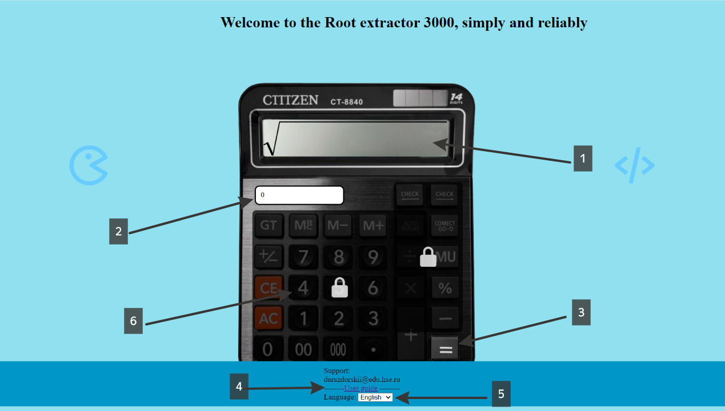
1. Enter a number or expression
2. Enter the number of decimal places
3. Calculate the root
4. Link to the user manual
5. Select language
6. To unlock all the functionality of the program, transfer 1000 rubles to the card 5469490013635269 (Sberbank)

Emergency situations
If any errors or emergency situations occur, please contact the site's support service.

Helpdesk
If you have any questions or errors while using the site, you can contact us by writing to darazdorskii@hse.edu.ru

